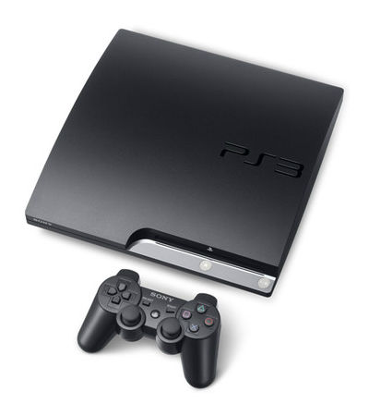
After the success of the original Sony PlayStation,, followed by the record setting sales of PlayStation 2,, the most popular home gaming console to date, Sony Computer Entertainment tasked its team with creating an even more dynamic gaming experience. The result was the Sony PlayStation 3,, released as a seventh generation console in 2006. The system marks huge improvements in all categories over its predecessors, including gameplay, multiplayer features, online gaming capabilities, and additional media services.

Beyond Gaming Capabilities
What set the PlayStation 3 apart from other seventh generation gaming consoles, the Xbox 360 and Nintendo Wii in particular, was its ability to function as an all-around media system with many uses beyond gaming. The PlayStation 3 functions as a Blu-Ray player, DVD player, and CD player, offering both high definition picture and surround sound audio. The console also offers Bluetooth 2.0 connectivity in addition to a game processor that is also used in the construction of super computers, providing users with unmatched graphics and gameplay compared to other consoles.
PlayStation 3 features its own photo gallery viewing and storage feature and can also link to Facebook to browse photos online. In addition to DVD and Blu-Ray capabilities, the system can connect to YouTube and Facebook to stream videos from the Internet. Netflix is also featured on the Sony PlayStation 3, allowing users to order movies directly from the console and watch them immediately. A number of video services have been added in recent years, including a partnership with Direct TV that allows users to access MLB TV and NFL Sunday Ticket programming, and an Amazon Instant Video application that provides even more television series and movies to the already wide selection available.
The Sony PlayStation 3 also interacts with the Sony PlayStation Portable, or PSP, in a number of unique ways. Classic PlayStation video games can be downloaded in the PS3 store and then transferred to the PSP for remote play. Some PS3 games allow for further interaction between the devices: racing games, for example, will utilize the PSP as a real time rear view mirror. Instead of switching camera angles, gamers can simply glance down at the PSP to get a view of the road behind them.

PlayStation 3 in the Seventh Generation of Game Consoles
The PlayStation 3 competes with the Xbox 360 and Nintendo Wii. The Nintendo Wii is immediately viewed as either the weakest option, or the most economic, depending on what you are looking for in a system. In order to focus on gameplay, the Wii can only play Nintendo Wii and GameCube discs. DVDs, Blu-Ray discs, and even CDs are not compatible with the console. If you are looking for an all-in-one type of media experience, the Wii is not the way to go.
While Microsoft's Xbox 360 can handle DVDs, it does not offer the same definition as the PlayStation 3 and it cannot play Blu-Ray movies or games. Likewise, the Xbox 360 offers a similar all-around media experience, but it requires an expensive Wi-Fi startup kit to get the most out of the Xbox Live Experience, whereas the PS3 is ready for the Internet out of the box. Xbox users have to pay an additional annual fee for an Xbox Live membership , whereas the PlayStation network is free.

Popular PlayStation 3 Games
The PlayStation 3 offers most major game releases for North America other than those exclusive to the Nintendo and Microsoft libraries. PlayStation 3 games range all genres, including first person and third person shooters, racing games, and several sports franchises.
Title | Description
"Call of Duty" and "Call of Duty: Black Ops" series | Not only do these two Call of Duty series provide the one of the all-time bestselling first person shooter experience, they account for the a large percentage of the online gaming community in the seventh generation of consoles.
"Grand Theft Auto IV & V" | In the same way "Grand Theft Auto III" and "San Andreas" were revolutionary for the Sony PlayStation 2, GTA IV embodies the PlayStation 3 gaming experience. Vivid, realistic graphics play into a game that features elements of action platforms, racing games, first and third person shooters, RPGs, and even dating games.
"FIFA" series | Another wildly popular online game, EA Sports' FIFA franchise is annually one of the top sellers for the PlayStation 3. No other comparable soccer game provides such an accurate simulation of the sport, with full licenses to the world's most popular clubs, players and stadiums.

How to Use a PlayStation 3 Controller
The PlayStation 3 controller is similar in design to the classic PlayStation 2 controller. Much like the PlayStation 2 controller slightly tweaked the original, the PlayStation 3 is slightly modified for an enhanced gameplay experience. Before you can successfully play any PlayStation 3 game, you will need to familiarize yourself with the various buttons and overall layout of the PS3 controller.
The most distinct difference between PS2 and PS3 controllers is the latter's wireless capabilities, as well as its rechargeable battery. The layout is essentially the same, designed in a horseshoe manner with two handles. The left handle contains the directional pad, or d-pad, and the right side features "action" buttons: a triangle, square, circle and X. These buttons usually make game characters jump, attack and shoot. The handles are connected by a narrow bridge featuring the Start and Select buttons as well as the dual analogue sticks. Four triggers are found on the back of the controller: L1 and L2 on the left side and R1 and R2 on the right. Traditional controllers are all black, but several other colors and finishes are available for purchase.

Setting Up Your PlayStation 3
Before you can use your PlayStation 3 you will need to set it up, which is easier than with many other consoles. First, connect to a TV. The PS3 can be connected at high definition or standard definition, depending on your television and the types of A/V cables you have, ranging from 480i to 1080p quality. A standard A/V cable comes with the system, while an HDMi cable must be purchased separately. After you have connected to the TV, you only need to plug the system's AC power cord into an outlet and connect an Ethernet cable in order to utilize the console's online gaming and video streaming services.

Buying a PlayStation 3 from Market / OLX
A number of models for the PlayStation 3 have been released, each working out any bugs, increasing overall gameplay and picture quality, and increasing storage. Only three of the roughly twelve models are still produced, though you can still buy used, outdated models at a discount. The original Sony PlayStation 3 featured a 20GB hard drive, while the new "super slim" models come in 12GB, 250GB and 500GB editions. As you can imagine, they range in price based on the amount of storage. The 12GB model is not available from traditional North American vendors, while the 500GB super slim model is the most popular model. & the purpose of purchasing an older model is to save money.

Conclusion
In many ways the Sony PlayStation 3 is one of the soundest investments you can make into a media player. Audio, two formats of video, online streaming and search functions plus the ability to download classic PlayStation games make the PS3 much more valuable than its price tag. With an easy set up that requires no additional accessories or fees to get online, the PS3 is a great buy.

Types of PlayStation 3

There are 3 types of PS3 and only two of them can be software modified (Jailbreak) to copy OR download original games and play without original CDs and one console needs Hardware Modification (Cobra Jailbreak)

Jailbreak Series are as followed:
- CECH-0xxx to CECH-2999 (All are Jail breakable consoles with this serial)
- CECH-3xxx to CECH-4999 (All are Cobra Jail breakable / Hardware modification enabled)

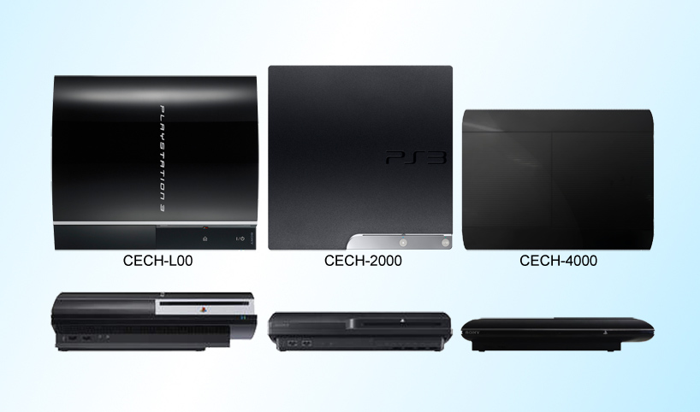

It’s best to buy a Jailbreak Console in Pakistan and other Asian countries. A average PS3 Game Disk cost is approx. 1500/= of year 2008 games. And latest series like GTA 5, FIFA 15, LAST OF US, ETC are for 4000 to 6000

